**Class Members**

The class members are declared in the body of a class.

These may comprise fields (variables in a class), methods, nested classes, and interfaces. The members of a class comprise the members declared in the class as well as the members inherited from a super class.

The scope of all the members extends to the entire class body. The fields comprise two types of variables:

1. Non-static variables: These include local and instance variables which vary in scope and value.

(a) Instance variables: These variables are individual to an object and an object keeps a copy of these variables in its memory.

(b) Local variables: These are local in scope and not accessible outside their scope.

2. Class variables: These variables are also qualified as static variables. The values of these variables are common to all the objects of the class. The class keeps only one copy of these variables and all the objects share the same copy. As class variables belong to the whole class, these are also called class variables.

Key Points :

1. Instance variables across different objects have different values, whereas class variables across different objects have only one value.
2. Class variables are initialized when a class is first loaded into JVM memory,
3. whereas instance variables are initialized when an instance is created.

**Example**

class CustomerId {

// initializing count to zero.

static int count = 0;// static variable

int id;// instance variable

public CustomerId() { // Every time the constructor runs, it increments count.

count = count + 1;

id = count;

}

public int getId()

{ return id; }

}

public class Application

{

public static void main (String args[])

{

CustomerId obj = new CustomerId();

System.out.println("Customer ID number:"+obj.getId());

}

}

**Declaration of Class Objects**

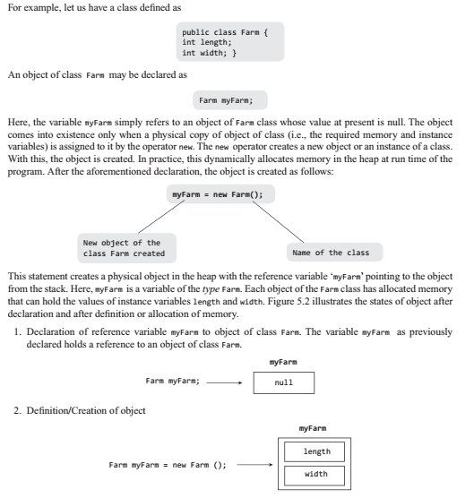

**Assigning One Object to Another**

class Farm

{

double length;

double width;

double area(){return length*width;}

}

public class FarmExe1

{

// class with main method().

public static void main (String args [])

{

Farm farm1 = new Farm();//defining an object farm1

Farm farm2 = new Farm(); //defining an object farm2

farm1.width = 20.0;// accessing the variables

farm1.length = 40.0;

System.out.println ("Area of farm1 = " + farm1.area());

farm2 = farm1;

System.out.println ("Area of farm2 = " + farm2.area());

farm2.width = 25;

System.out.println ("Width of farm2 = " + farm2.width);

System.out.println ("Width of farm1 = " + farm1.width);

System.out.println ("Area of farm1 = " + farm1.area());

}

}